ASSIGNMENT-4

Docker and Kubernetes

|  |  |
| --- | --- |
| **Student Name** | **Santosh B** |
| **Student Roll Number** | **727719EUCS122** |
| **Maximum Marks** | **2 Marks** |

1. **Pull an image from docker hub and run it in docker playground:**

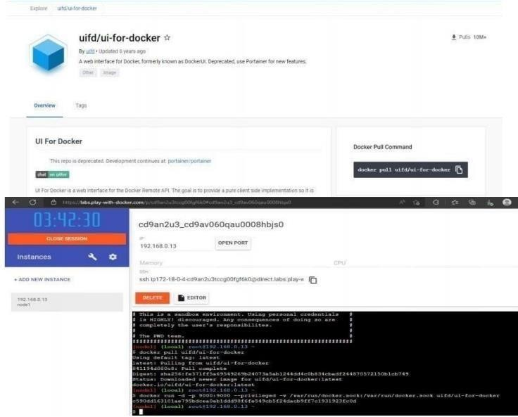

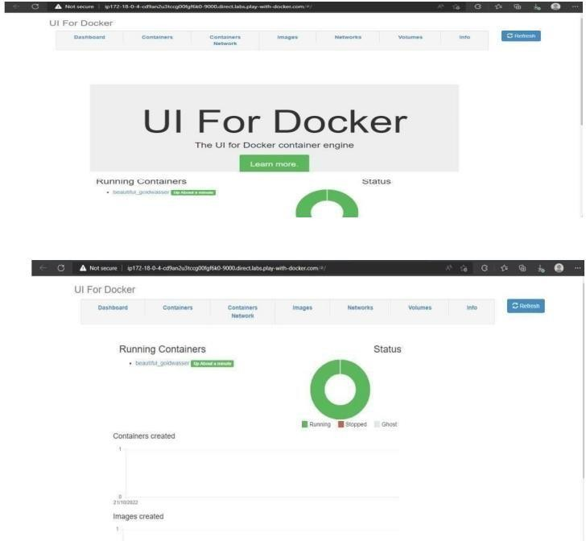

1. **Create a docker file for the jobportal application and deploy it in Docker desktop application:**

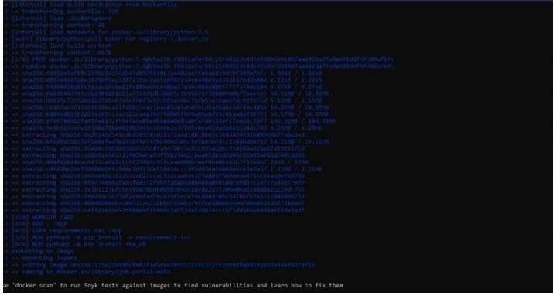

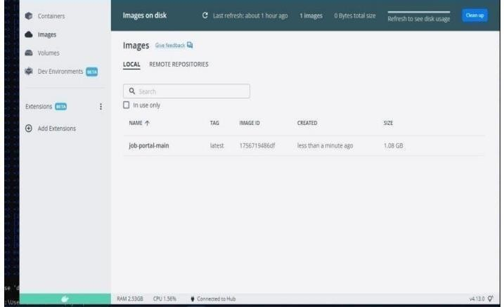

1. **Create a IBM container registry and deploy helloworld app or jobportal app:**

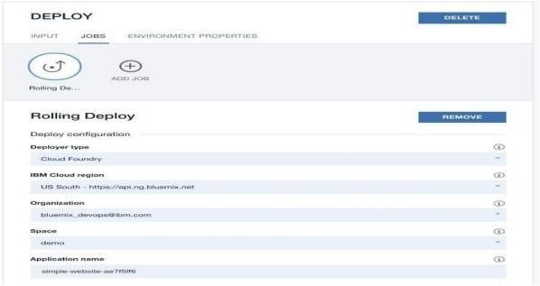

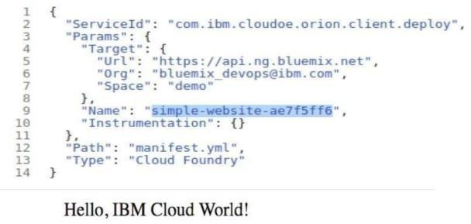

1. **Create a Kubernetes cluster in IMB cloud and deploy helloworld image or jobportal imageand also expose the same app to run nodeport:**

